without adv

1 run...

Downloading: 100%

411/411 [00:00<00:00, 15.0kB/s]

Downloading: 100%

263M/263M [00:06<00:00, 44.3MB/s]

training 1 epoch...

736.0225582122803 seconds used......

1 training finished! average train loss: 0.38522307382475945

evaluating...

Confusion matrix, without normalization

[[ 529 236 257]

[ 477 4696 234]

[ 365 302 10098]]

Normalized confusion matrix

[[0.51761252 0.23091977 0.25146771]

[0.08821898 0.86850379 0.04327723]

[0.03390618 0.02805388 0.93803994]]

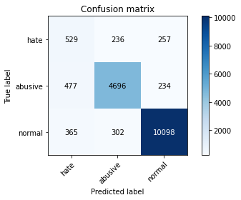

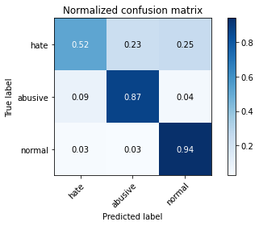

precision recall f1-score support

hate 0.39 0.52 0.44 1022

abusive 0.90 0.87 0.88 5407

normal 0.95 0.94 0.95 10765

accuracy 0.89 17194

macro avg 0.75 0.77 0.76 17194

weighted avg 0.90 0.89 0.90 17194

average eval_loss: 0.3255138298020113, accuracy: 0.8911829708037687

training 2 epoch...

735.2626159191132 seconds used......

2 training finished! average train loss: 0.29538920305975197

evaluating...

Confusion matrix, without normalization

[[ 350 371 301]

[ 140 5029 238]

[ 123 371 10271]]

Normalized confusion matrix

[[0.34246575 0.3630137 0.29452055]

[0.02589236 0.93009062 0.04401701]

[0.01142592 0.03446354 0.95411054]]

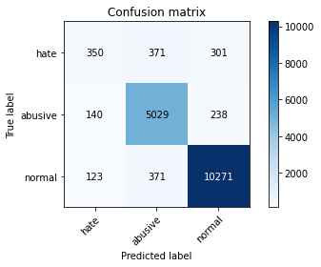

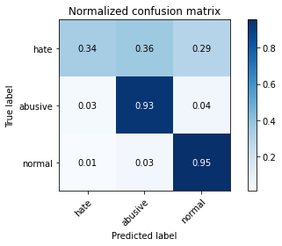

precision recall f1-score support

hate 0.57 0.34 0.43 1022

abusive 0.87 0.93 0.90 5407

normal 0.95 0.95 0.95 10765

accuracy 0.91 17194

macro avg 0.80 0.74 0.76 17194

weighted avg 0.90 0.91 0.90 17194

average eval_loss: 0.2794185305014253, accuracy: 0.9102012329882517

training 3 epoch...

735.123363494873 seconds used......

3 training finished! average train loss: 0.2151470183711663

evaluating...

Confusion matrix, without normalization

[[ 525 254 243]

[ 439 4759 209]

[ 528 355 9882]]

Normalized confusion matrix

[[0.51369863 0.24853229 0.23776908]

[0.08119105 0.88015535 0.0386536 ]

[0.04904784 0.03297724 0.91797492]]

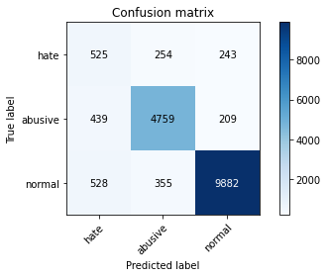

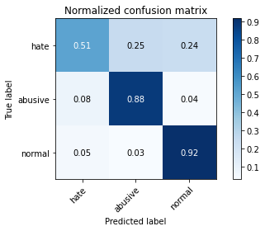

precision recall f1-score support

hate 0.35 0.51 0.42 1022

abusive 0.89 0.88 0.88 5407

normal 0.96 0.92 0.94 10765

accuracy 0.88 17194

macro avg 0.73 0.77 0.75 17194

weighted avg 0.90 0.88 0.89 17194

average eval_loss: 0.3574318359540992, accuracy: 0.8820518785622892

training 4 epoch...

735.1201784610748 seconds used......

4 training finished! average train loss: 0.14017226307651526

evaluating...

Confusion matrix, without normalization

[[ 485 292 245]

[ 407 4805 195]

[ 473 370 9922]]

Normalized confusion matrix

[[0.47455969 0.28571429 0.23972603]

[0.07527279 0.88866284 0.03606436]

[0.04393869 0.03437065 0.92169066]]

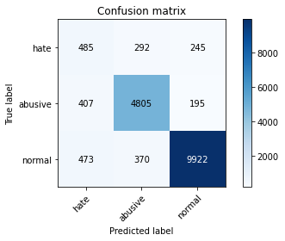

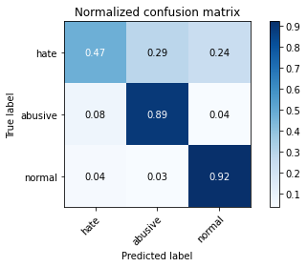

precision recall f1-score support

hate 0.36 0.47 0.41 1022

abusive 0.88 0.89 0.88 5407

normal 0.96 0.92 0.94 10765

accuracy 0.88 17194

macro avg 0.73 0.76 0.74 17194

weighted avg 0.90 0.88 0.89 17194

average eval_loss: 0.4085745602921951, accuracy: 0.8847272304292195

training 5 epoch...

735.2032272815704 seconds used......

5 training finished! average train loss: 0.10238211379050895

evaluating...

Confusion matrix, without normalization

[[ 435 333 254]

[ 335 4842 230]

[ 391 372 10002]]

Normalized confusion matrix

[[0.42563601 0.3258317 0.24853229]

[0.06195672 0.89550583 0.04253745]

[0.03632141 0.03455643 0.92912216]]

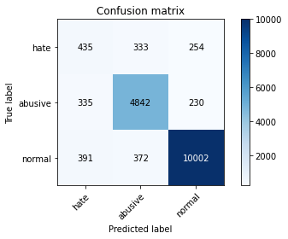

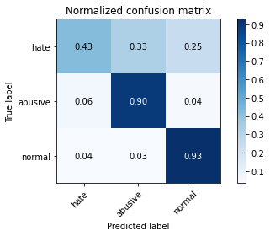

precision recall f1-score support

hate 0.37 0.43 0.40 1022

abusive 0.87 0.90 0.88 5407

normal 0.95 0.93 0.94 10765

accuracy 0.89 17194

macro avg 0.73 0.75 0.74 17194

weighted avg 0.89 0.89 0.89 17194

average eval_loss: 0.4661195287730025, accuracy: 0.8886239385832267

2 run...

training 1 epoch...

735.1123201847076 seconds used......

1 training finished! average train loss: 0.38545337482970043

evaluating...

Confusion matrix, without normalization

[[ 430 315 277]

[ 213 5004 190]

[ 203 400 10162]]

Normalized confusion matrix

[[0.42074364 0.30821918 0.27103718]

[0.03939338 0.92546699 0.03513963]

[0.01885741 0.03715745 0.94398514]]

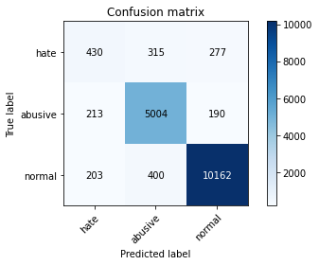

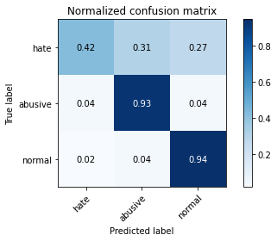

precision recall f1-score support

hate 0.51 0.42 0.46 1022

abusive 0.87 0.93 0.90 5407

normal 0.96 0.94 0.95 10765

accuracy 0.91 17194

macro avg 0.78 0.76 0.77 17194

weighted avg 0.90 0.91 0.91 17194

average eval_loss: 0.28919661246500045, accuracy: 0.9070606025357683

training 2 epoch...

735.0572974681854 seconds used......

2 training finished! average train loss: 0.2958311320752277

evaluating...

Confusion matrix, without normalization

[[ 400 332 290]

[ 237 4958 212]

[ 189 348 10228]]

Normalized confusion matrix

[[0.39138943 0.32485323 0.28375734]

[0.04383207 0.9169595 0.03920843]

[0.0175569 0.03232699 0.95011612]]

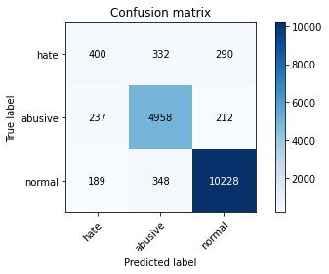

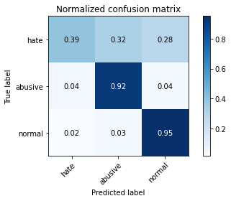

precision recall f1-score support

hate 0.48 0.39 0.43 1022

abusive 0.88 0.92 0.90 5407

normal 0.95 0.95 0.95 10765

accuracy 0.91 17194

macro avg 0.77 0.75 0.76 17194

weighted avg 0.90 0.91 0.90 17194

average eval_loss: 0.2889058327453947, accuracy: 0.9064790043038269

training 3 epoch...

734.8918809890747 seconds used......

3 training finished! average train loss: 0.21782532687841086

evaluating...

Confusion matrix, without normalization

[[ 455 263 304]

[ 384 4701 322]

[ 286 293 10186]]

Normalized confusion matrix

[[0.44520548 0.25733855 0.29745597]

[0.07101905 0.86942852 0.05955243]

[0.02656758 0.02721784 0.94621458]]

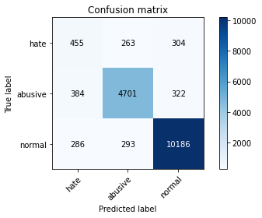

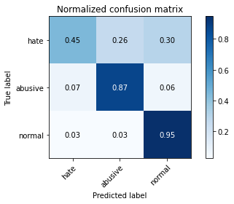

precision recall f1-score support

hate 0.40 0.45 0.42 1022

abusive 0.89 0.87 0.88 5407

normal 0.94 0.95 0.94 10765

accuracy 0.89 17194

macro avg 0.75 0.75 0.75 17194

weighted avg 0.90 0.89 0.89 17194

average eval_loss: 0.34324773323050767, accuracy: 0.8922880074444574

training 4 epoch...

735.3449785709381 seconds used......

4 training finished! average train loss: 0.14564239931234113

evaluating...

Confusion matrix, without normalization

[[ 483 280 259]

[ 417 4750 240]

[ 437 364 9964]]

Normalized confusion matrix

[[0.47260274 0.2739726 0.25342466]

[0.07712225 0.87849085 0.04438691]

[0.04059452 0.03381328 0.9255922 ]]

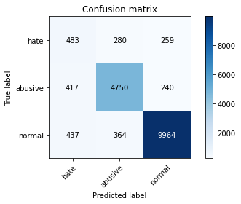

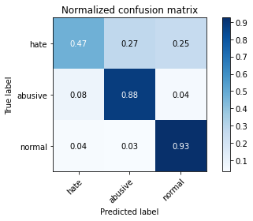

precision recall f1-score support

hate 0.36 0.47 0.41 1022

abusive 0.88 0.88 0.88 5407

normal 0.95 0.93 0.94 10765

accuracy 0.88 17194

macro avg 0.73 0.76 0.74 17194

weighted avg 0.89 0.88 0.89 17194

average eval_loss: 0.4119138374226168, accuracy: 0.8838548330813074

training 5 epoch...

735.7152709960938 seconds used......

5 training finished! average train loss: 0.09875487847346881

evaluating...

Confusion matrix, without normalization

[[ 408 326 288]

[ 339 4829 239]

[ 315 333 10117]]

Normalized confusion matrix

[[0.39921722 0.31898239 0.28180039]

[0.0626965 0.89310154 0.04420196]

[0.0292615 0.03093358 0.93980492]]

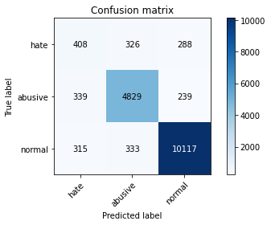

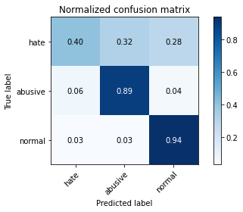

precision recall f1-score support

hate 0.38 0.40 0.39 1022

abusive 0.88 0.89 0.89 5407

normal 0.95 0.94 0.95 10765

accuracy 0.89 17194

macro avg 0.74 0.74 0.74 17194

weighted avg 0.89 0.89 0.89 17194

average eval_loss: 0.5103659793447574, accuracy: 0.892985925322787